| PBO TUGAS AKHIR PBOInayah Dwi Utari | 18 |XI RPL 5SMK TELKOM MALANG | |  | | --- |   PROJECT PORTOFOLIO SUSU’in / (APLIKASI PenjualanDENGAN PROGRAM NETBEANSBERBASIS BAHASA JAVA)   **SMK TELKOM MALANG**  Alamat : Jl. Danau Ranau Sawojajar, Kota Malang  Website : www.smktelkom-mlg.sch.id  Tahun Ajaran 2017/2018 |
| --- | --- | --- |

### Tentang aplikasi

**Deskripsi Tentang Aplikasi:**

SUSU’in merupakan aplikasi jual beli dimana menu-menu disediakan secara online.

**Fitur :**

1. Memudahkan pembeli dalam membeli produk
2. Memudahkan owner menyimpan data pelanggan
3. Memudahkan owner dalam proses jual beli

**Keunggulan :**

* Tampilan yang user friendly

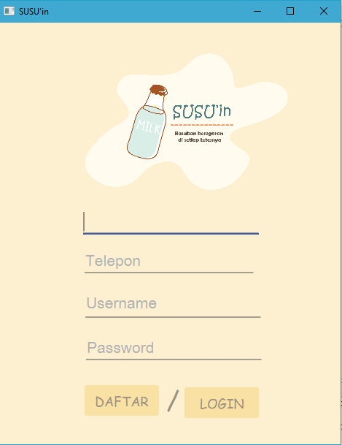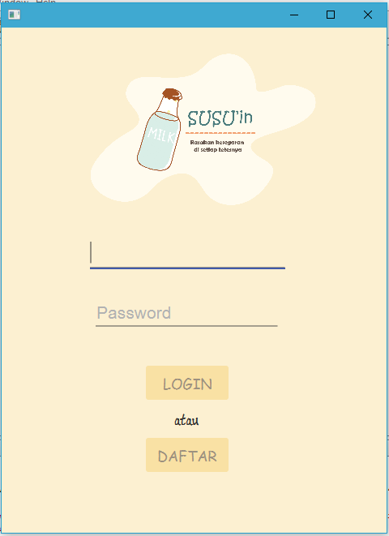

* Terdapat banyak pilihan menu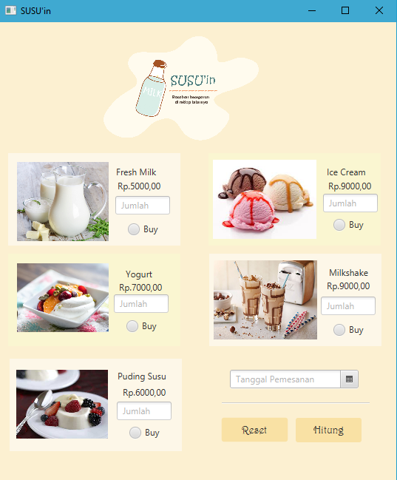

### lANGKAH pEMBUATAN APLIKASI

1. Langkah pertama yang perlu kita lakukan adalah memasukkan library **.** Pilih project kita, buka **Libraries.** Klik kanan → Add JAR/Folder

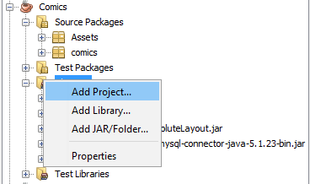

1. Langkah kedua yang dilakukan adalah memasukkan asset – asset yang diperlukan dalam project. Dengan cara, Klik kanan pada Source Package → New → Java Package → Beri nama → Finish

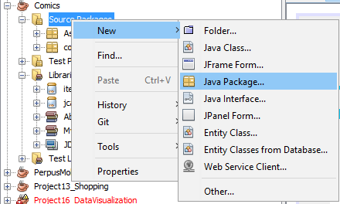

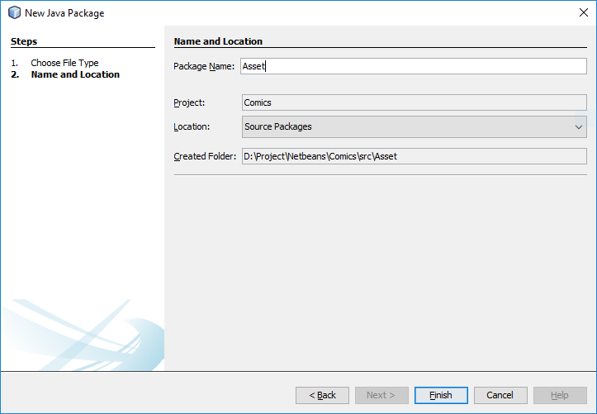

1. Kemudian Copy Assets yang dibutuhkan dan paste pada folder tersebut. Apabila berhasil maka file file akan tertata dibawahnya



1. Buat Frame – frame yang akan digunakan dengan cara, Klik kanan Source Packages → New → JFrame Form.





1. Tambahkan juga library mySQL dengan cara Klik Kanan Libraries → Add Library → Pilih MySQL JDBC Driver → Add Library.

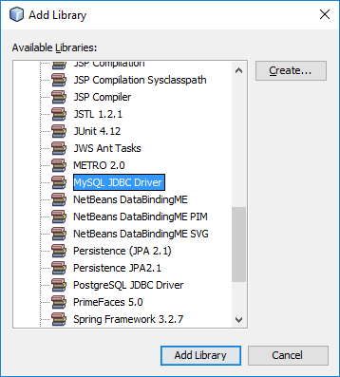

1. Buat database pada phpMyAdmin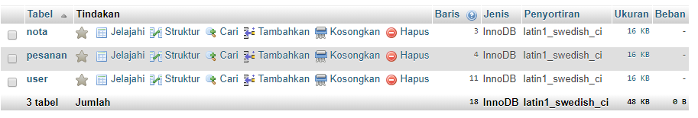
2. Kemudian Buat File Koneksi ke database. Buat class baru, dan tulis kode dibawah ini

package koneksi;

import java.sql.*;

/**

*

* @author Naya

*/

public class kon {

static final String C_DRIVER = "com.mysql.jdbc.Driver";

static final String DB_URL = "jdbc:mysql://localhost/susuin";

static final String USER = "root";

static final String PASS ="";

public static Connection Konek(){

Connection conn = null;

try{

Class.forName(C_DRIVER);

conn = (Connection) DriverManager.getConnection(DB_URL, USER, PASS);

} catch (ClassNotFoundException | SQLException ex){

}

return conn;

}

}

1. Setelah selesai dengan file database, kita akan melanjutkan menuju bagian login.

package susuin;

import com.jfoenix.controls.JFXButton;

import com.jfoenix.controls.JFXPasswordField;

import com.jfoenix.controls.JFXTextField;

import java.io.IOException;

import java.net.URL;

import java.sql.Connection;

import java.sql.PreparedStatement;

import java.sql.ResultSet;

import java.sql.SQLException;

import java.util.ResourceBundle;

import javafx.event.ActionEvent;

import javafx.fxml.FXML;

import javafx.fxml.FXMLLoader;

import javafx.fxml.Initializable;

import javafx.scene.Node;

import javafx.scene.Scene;

import javafx.stage.Stage;

import javax.swing.JOptionPane;

/**

* FXML Controller class

*

* @author Naya

*/

public class LoginController implements Initializable {

@FXML

private JFXTextField username;

@FXML

private JFXPasswordField password;

@FXML

private JFXButton login;

String user, pass;

private Connection conn = null;

private ResultSet rs = null;

private PreparedStatement stmt = null;

@FXML

private JFXButton daftar;

/**

* Initializes the controller class.

* @param url

* @param rb

*/

@Override

public void initialize(URL url, ResourceBundle rb) {

// TODO

}

@FXML

private void Login(ActionEvent event) {

// tampilUser.setText(username);

// tampilPass.setText(password);

conn = koneksi.kon.Konek();

user = username.getText();

pass = password.getText();

String sql = "Select * from user where username = ? && password = ?";

try {

stmt= conn.prepareStatement(sql);

stmt.setString(1, user);

stmt.setString(2, pass);

rs = stmt.executeQuery();

if (rs.next()){

try {

// Hide this current window (if this is what you want)

((Node)(event.getSource())).getScene().getWindow().hide();

// Load the new fxml

FXMLLoader fxmlLoader = new FXMLLoader();

fxmlLoader.setLocation(getClass().getResource("susu.fxml"));

Scene scene = new Scene(fxmlLoader.load());

// Create new stage (window), then set the new Scene

Stage stage = new Stage();

stage.setScene(scene);

stage.setTitle("SUSU'in");

stage.show();

} catch (IOException e) {

System.out.println("Failed to create new Window." + e);

}

}

else if(username.getText().equals("") || password.getText().equals("")){

JOptionPane.showMessageDialog(null,"Masukkan Username dan Password!!!");

}

else {

JOptionPane.showMessageDialog(null,"Username dan Password salah!!!");

}

stmt.close();

conn.close();

} catch (SQLException se) {

JOptionPane.showMessageDialog(null, se);

}catch(Exception e){

JOptionPane.showMessageDialog(null, e);

}finally{

try{

if (stmt != null){

stmt.close();

}

}catch(SQLException se){

se.printStackTrace();

}

}

}

@FXML

void daftar(ActionEvent event) {

try {

// Hide this current window (if this is what you want)

((Node)(event.getSource())).getScene().getWindow().hide();

// Load the new fxml

FXMLLoader fxmlLoader = new FXMLLoader();

fxmlLoader.setLocation(getClass().getResource("daftar.fxml"));

Scene scene = new Scene(fxmlLoader.load());

// Create new stage (window), then set the new Scene

Stage stage = new Stage();

stage.setScene(scene);

stage.setTitle("SUSU'in");

stage.show();

} catch (IOException e) {

System.out.println("Failed to create new Window." + e);

}

}

}

1. Lanjut menuju daftar

package susuin;

import com.jfoenix.controls.JFXButton;

import com.jfoenix.controls.JFXPasswordField;

import com.jfoenix.controls.JFXTextField;

import java.io.IOException;

import java.net.URL;

import java.sql.Connection;

import java.sql.PreparedStatement;

import java.sql.ResultSet;

import java.sql.SQLException;

import java.util.ResourceBundle;

import javafx.event.ActionEvent;

import javafx.fxml.FXML;

import javafx.fxml.FXMLLoader;

import javafx.fxml.Initializable;

import javafx.scene.Node;

import javafx.scene.Scene;

import javafx.stage.Stage;

import javax.swing.JOptionPane;

/**

* FXML Controller class

*

* @author Naya

*/

public class DaftarController implements Initializable {

public String user, pass, nam, telp;

@FXML

private JFXTextField username;

@FXML

private JFXPasswordField password;

@FXML

private JFXButton daftar;

@FXML

private JFXButton log_in;

@FXML

private JFXTextField nama;

private Connection conn = null;

private ResultSet rs = null;

private PreparedStatement stmt = null;

@FXML

private JFXTextField telepon;

/**

* Initializes the controller class.

*/

@Override

public void initialize(URL url, ResourceBundle rb) {

conn = koneksi.kon.Konek();

// TODO

}

@FXML

private void daftar(ActionEvent event) throws SQLException {

conn = koneksi.kon.Konek();

user = username.getText();

pass = password.getText();

nam = nama.getText();

telp = telepon.getText();

String sql = "INSERT INTO `user`(`nama`,`telepon`,`username`,`password`) VALUES (?,?,?,?)";

try {

stmt= conn.prepareStatement(sql);

stmt.setString(1, nam);

stmt.setString(3, user);

stmt.setString(4, pass);

stmt.setString(2, telp);

int i = stmt.executeUpdate();

if(nama.getText().equals("")||telepon.getText().equals("")||username.getText().equals("")||password.getText().equals("")){

JOptionPane.showMessageDialog(null, "Lengkapi Data Anda!!!");

}

else if (i == 1){

JOptionPane.showMessageDialog(null,"Daftar Berhasil");

try {

// Hide this current window (if this is what you want)

((Node)(event.getSource())).getScene().getWindow().hide();

// Load the new fxml

FXMLLoader fxmlLoader = new FXMLLoader();

fxmlLoader.setLocation(getClass().getResource("login.fxml"));

Scene scene = new Scene(fxmlLoader.load());

// Create new stage (window), then set the new Scene

Stage stage = new Stage();

stage.setScene(scene);

stage.setTitle("SUSU'in");

stage.show();

} catch (IOException e) {

System.out.println("Failed to create new Window." + e);

}

}

else{

JOptionPane.showMessageDialog(null,"Maaf anda gagal mendaftar");

}

stmt.close();

conn.close();

} catch (SQLException se) {

JOptionPane.showMessageDialog(null, se);

}catch(Exception e){

JOptionPane.showMessageDialog(null, e);

}finally{

try{

if (stmt != null){

stmt.close();

}

}catch(SQLException se){

se.printStackTrace();

}

}

}

@FXML

void log_in(ActionEvent event) {

try {

// Hide this current window (if this is what you want)

((Node)(event.getSource())).getScene().getWindow().hide();

// Load the new fxml

FXMLLoader fxmlLoader = new FXMLLoader();

fxmlLoader.setLocation(getClass().getResource("login.fxml"));

Scene scene = new Scene(fxmlLoader.load());

// Create new stage (window), then set the new Scene

Stage stage = new Stage();

stage.setScene(scene);

stage.setTitle("SUSU'in");

stage.show();

} catch (IOException e) {

System.out.println("Failed to create new Window." + e);

}

}

}

1. Berikutnya Menu

package susuin;

import com.jfoenix.controls.JFXTextField;

import java.io.IOException;

import java.net.URL;

import java.sql.Connection;

import java.sql.PreparedStatement;

import java.sql.ResultSet;

import java.sql.SQLException;

import java.time.LocalDate;

import java.util.ResourceBundle;

import javafx.event.ActionEvent;

import javafx.fxml.FXML;

import javafx.fxml.FXMLLoader;

import javafx.fxml.Initializable;

import javafx.scene.Node;

import javafx.scene.Scene;

import javafx.scene.control.Button;

import javafx.scene.control.DatePicker;

import javafx.scene.control.RadioButton;

import javafx.scene.control.TextField;

import javafx.stage.Stage;

import javax.swing.JOptionPane;

/**

* FXML Controller class

*

* @author Naya

*/

public class SususayaController implements Initializable {

@FXML

private Button Reset;

@FXML

private Button hitung;

@FXML

private JFXTextField biaya;

@FXML

private TextField jumlahsusu;

@FXML

private TextField jumlahyogurt;

@FXML

private TextField jumlahpudingsusu;

@FXML

private TextField jumlahicecream;

@FXML

private TextField jumlahmilkshake;

@FXML

private DatePicker tanggal;

private Connection conn = null;

private PreparedStatement stmt = null;

@FXML

private RadioButton buysusu;

@FXML

private RadioButton buyyogurt;

@FXML

private RadioButton buypudingsusu;

@FXML

private RadioButton buyicecream;

@FXML

private RadioButton buymilkshake;

int jumlahmakan1 =0,jumlahmakan2=0,jumlahmakan3=0,jumlahmakan4=0,jumlahmakan5=0;

int hagatotal1,hagatotal2,hagatotal3,hagatotal4,hagatotal5,hagatotal6,hagatotal7,hagatotal8;

String menu="";

String pilih1, pilih2, pilih3, pilih4, pilih5,tgl;

int harga;

public int totalbayar;

private ResultSet rs = null;

/**

* Initializes the controller class.

*/

@Override

public void initialize(URL url, ResourceBundle rb) {

conn = koneksi.kon.Konek();

}

@FXML

private void reset(ActionEvent event) {

jumlahsusu.setText("");

jumlahpudingsusu.setText("");

jumlahicecream.setText("");

jumlahmilkshake.setText("");

jumlahyogurt.setText("");

tanggal.setValue(LocalDate.now());

buysusu.setSelected(false);

buyyogurt.setSelected(false);

buypudingsusu.setSelected(false);

buymilkshake.setSelected(false);

buyicecream.setSelected(false);

}

@FXML

private void hitung(ActionEvent event) {

if(buysusu.isSelected()){

pilih1 = "Fresh Milk : "+jumlahsusu.getText() +", " ;

harga = 5000;

menu +=buysusu.getText()+", ";

jumlahmakan1+=Integer.parseInt(jumlahsusu.getText());

hagatotal1=harga*jumlahmakan1;

System.out.println(hagatotal1);

}

if(buyyogurt.isSelected()){

pilih2 = "Yogurt : "+jumlahyogurt.getText() +", " ;

harga = 7000;

menu += buyyogurt.getText()+", ";

jumlahmakan2+=Integer.parseInt(jumlahyogurt.getText());

hagatotal2=harga*jumlahmakan2;

System.out.println(hagatotal2);

}

if(buypudingsusu.isSelected()){

pilih3 = "Puding Susu : "+jumlahpudingsusu.getText()+", ";

harga = 6000;

menu += buypudingsusu.getText()+", ";

jumlahmakan3+=Integer.parseInt(jumlahpudingsusu.getText());

hagatotal3=harga*jumlahmakan3;

System.out.println(hagatotal3);

}

if(buyicecream.isSelected()){

pilih4 = "Ice Cream : "+jumlahicecream.getText()+",";

harga = 9000;

menu += buyicecream.getText()+", ";

jumlahmakan4+=Integer.parseInt(jumlahicecream.getText());

hagatotal4=harga*jumlahmakan4;

System.out.println(hagatotal4);

}

if(buymilkshake.isSelected()){

pilih5 = "Milkshake : "+jumlahmilkshake.getText()+",";

harga = 9000;

menu += buymilkshake.getText()+", ";

jumlahmakan5+=Integer.parseInt(jumlahmilkshake.getText());

hagatotal5=harga*jumlahmakan5;

System.out.println(hagatotal5);

}

totalbayar = hagatotal1+hagatotal2+hagatotal3+hagatotal4+hagatotal5+hagatotal6+hagatotal7+hagatotal8;

conn = koneksi.kon.Konek();

tgl = tanggal.getValue().toString();

String ttl = String.valueOf(totalbayar);

String js = String.valueOf(jumlahmakan1);

String jy = String.valueOf(jumlahmakan2);

String jp = String.valueOf(jumlahmakan3);

String ji = String.valueOf(jumlahmakan4);

String jm = String.valueOf(jumlahmakan5);

String sql = "INSERT INTO `pesanan`(`tanggal`,`totalbiaya`,`jumlahsusu`,`jumlahyogurt`,`jumlahpuding`,`jumlahicecream`,`jumlahmilkshake`) VALUES (?,?,?,?,?,?,?)";

try {

stmt= conn.prepareStatement(sql);

stmt.setString(1,tgl);

stmt.setString(2, ttl);

stmt.setString(3,js );

stmt.setString(4, jy);

stmt.setString(5, jp);

stmt.setString(6, ji);

stmt.setString(7, jm);

int i = stmt.executeUpdate();

if(i==1){

try {

// Hide this current window (if this is what you want)

((Node)(event.getSource())).getScene().getWindow().hide();

// Load the new fxml

FXMLLoader fxmlLoader = new FXMLLoader();

fxmlLoader.setLocation(getClass().getResource("notasusu.fxml"));

Scene scene = new Scene(fxmlLoader.load());

// Create new stage (window), then set the new Scene

Stage stage = new Stage();

stage.setScene(scene);

stage.setTitle("SUSU'in");

stage.show();

NotasusuController kirim= new NotasusuController();

kirim = fxmlLoader.getController();

kirim.total(totalbayar);

kirim.pilihan1(pilih1);

kirim.pilihan2(pilih2);

kirim.pilihan3(pilih3);

kirim.pilihan4(pilih4);

kirim.pilihan5(pilih5);

} catch (IOException e) {

System.out.println("Failed to create new Window." + e);

}

}

}

catch (SQLException se) {

JOptionPane.showMessageDialog(null, se);

}

}

}

1. Selanjutnya, Nota

package susuin;

import com.jfoenix.controls.JFXTextArea;

import com.jfoenix.controls.JFXTextField;

import java.io.IOException;

import java.net.URL;

import java.sql.Connection;

import java.sql.PreparedStatement;

import java.sql.ResultSet;

import java.sql.SQLException;

import java.util.ResourceBundle;

import javafx.event.ActionEvent;

import javafx.fxml.FXML;

import javafx.fxml.FXMLLoader;

import javafx.fxml.Initializable;

import javafx.scene.Node;

import javafx.scene.Scene;

import javafx.scene.control.Button;

import javafx.scene.layout.AnchorPane;

import javafx.stage.Stage;

/**

* FXML Controller class

*

* @author Naya

*/

public class NotasusuController implements Initializable {

String nam,nm ,t,ap,almt;

int tb;

@FXML

private AnchorPane pemesan;

@FXML

private JFXTextField telepon;

@FXML

private JFXTextField alamat;

@FXML

private JFXTextField biaya;

@FXML

private Button submit;

@FXML

private Button out;

@FXML

private JFXTextField nama;

@FXML

private JFXTextArea hasil;

private JFXTextArea hasil1;

@FXML

private JFXTextField pes1;

@FXML

private JFXTextField pes2;

@FXML

private JFXTextField pes3;

@FXML

private JFXTextField pes4;

@FXML

private JFXTextField pes5;

private Connection conn = null;

private ResultSet rs = null;

private PreparedStatement stmt = null;

/**

* Initializes the controller class.

*/

@Override

public void initialize(URL url, ResourceBundle rb) {

// TODO

conn = koneksi.kon.Konek();

}

public void total(int total){

biaya.setText(""+total);

}

@FXML

private void submit(ActionEvent event) throws SQLException {

conn = koneksi.kon.Konek();

nm = nama.getText();

t = telepon.getText();

almt = alamat.getText();

String sql = "INSERT INTO `nota`(`nama`,`telepon`,`alamat`) VALUES (?,?,?)";

stmt= conn.prepareStatement(sql);

stmt.setString(1, nm);

stmt.setString(2,t );

stmt.setString(3, almt);

int i = stmt.executeUpdate();

if(i==1){

nam=nama.getText();

t=telepon.getText();

ap=alamat.getText();

String tt=biaya.getText();

hasil.setText("Pemesan : "+nam+"\n"+"Nomor Telepon : "+t+"\n"+"Alamat : "+ap+"\n"+"Total Harga : "+tt);

}

}

public void pilihan1 (String pilihan1){

pes1.setText(""+pilihan1);

}

public void pilihan2 (String pilihan2){

pes2.setText(""+pilihan2);

}

public void pilihan3 (String pilihan3){

pes3.setText(""+pilihan3);

}

public void pilihan4 (String pilihan4){

pes4.setText(""+pilihan4);

}

public void pilihan5 (String pilihan5){

pes5.setText(""+pilihan5);

}

@FXML

private void out(ActionEvent event) {

try {

// Hide this current window (if this is what you want)

((Node)(event.getSource())).getScene().getWindow().hide();

// Load the new fxml

FXMLLoader fxmlLoader = new FXMLLoader();

fxmlLoader.setLocation(getClass().getResource("login.fxml"));

Scene scene = new Scene(fxmlLoader.load());

// Create new stage (window), then set the new Scene

Stage stage = new Stage();

stage.setScene(scene);

stage.setTitle("SUSU'in");

stage.show();

} catch (IOException e) {

System.out.println("Failed to create new Window." + e);

}

}

}

Link Project ada di sini <https://github.com/felliciawidianti/MalangTravell>